Ultra Carpetball Plans Version 3.0
The Best Free Carpetball Plans On The Web
A Matthew Campbell Creation

- Preparation
  - Read these instructions all the way through and look at all the diagrams before starting! It's important to have a visual picture in your head of what you'll be building, so make sure you understand what you're getting into!
  - Find out if you have a 4-foot by 22-foot space for a carpetball table (this includes room on each end and on the sides). Remember that you will put together the table where it will be played; it is too big and heavy to move after being assembled.
  - Choose between an easy table (24 inches wide) and a hard table (20 inches wide).
  - Choose between a "slow" table (balls don't roll as easily; uses thicker, more expensive carpet) or a "fast" table (balls roll with the slightest touch; uses thinner, cheaper carpet). Remember though, that the terms slow and fast are completely relative because that all depends on how fast you throw the cue ball.
    - Note: I have made a number of carpetball tables in my lifetime; some easy and "fast," and some hard and "slow." The majority of players, including myself, have decided that the hard and "slow" tables were much more exciting to play.
- Parts
  - Main Table Parts
    - Two (2): 10' x 1.5" x 7" Boards (Sides)
    - Two (2): 7' x 1.5" x 7" Boards (Sides)
    - Two (2): 1' x 1.5" x 7" Boards (Side Junctions)
    - Sixteen (16): 20" or 24" x 2" x 4" Boards (End Pieces, Struts Under Table)
    - One (1): 20" or 24" x 4" x 4" Board (Support for Plywood Junction)
    - Four (4): End Angled Supports (Work With Both 20" and 24" Tables) (See Diagram II.a.vi)
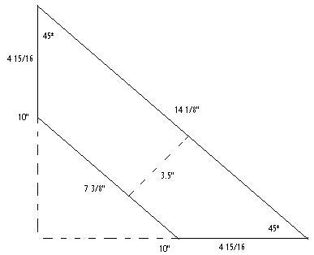
Diagram II.a.vi

    - Four (4): Center Angled Supports (Work With Both 20" and 24" Tables) (See Diagram II.a.vii)
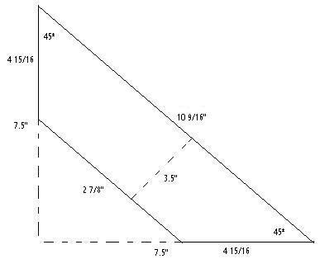
Diagram II.a.vii

    - Two (2): 20" or 24" x 90" x 3 or 4 Ply (.5 or .75 inch) Plywood Board (Playing Surface Base)
    - Two (2): 22" or 26" x 13.5" x 3 or 4 Ply (.5 or .75 inch) Plywood Boards (Ball Pits at Table Ends)
    - Note: Some builders prefer to use a longer side junction board, closer to 1.5’ rather than just 1’. This will also work fine if secured properly with extra wood screws.
  - Legs
    - Four (4): 34" x 4" x 4" Boards (End Table Legs (Seem High But They're Not); These MUST be AS ACURATE AS POSSIBLE!)
    - Two (2): 37.5" x 2" x 4" Boards (Center Table Legs (Seem High But They're Not); These MUST be AS ACURATE AS POSSIBLE!)
    - Six (6): 36" or 38.5" x 2" x 4" Boards (Cross Pieces To Support Legs)
    - Note I: Some builders like to use 2” x 8” boards instead of 2” x 4” boards for the middle legs- this will work just fine as long as their length is still correct, and allows you to put in more wood screws.
    - Note II: The 1.5" x 7" side boards are really 2" x 8" boards; the dimensions listed are rough rounded dimensions. I highly recommend measuring how tall these side boards are. If the side boards are 7" tall, make the two middle legs 37.5" tall as listed above. If the side boards are actually 7.25" tall, make the two middle legs 37.75" tall instead of just 37.5".
  - Carpet (See Diagrams II.c Slow and Fast)
    - One (1): 20" or 24" x 22' Piece of Carpet (Playing Surface)
    - Two (2): 200" x 3" Strips of Carpet (Walls)
    - Four (4): 9.5" x 3" Pieces of Carpet (Pit Walls)
    - Note I: If you cannot find a 22-foot piece of carpet, use two pieces and have them join in the middle. I used this method on both of my tables and it has worked fine. Just be careful not to join the pieces of carpet at the same place as the plywood junction (ie the 102-inch mark).
    - Note II: For many of the dimensions given, actual sizes (not commercially advertised sizes) were given. For example, a 2” x 4” board might be given as 1.5” x 3.5”. To see a list of actual sizes compared to advertised sizes, see http://www.engineersedge.com/commercial_lumber_sizes.htm
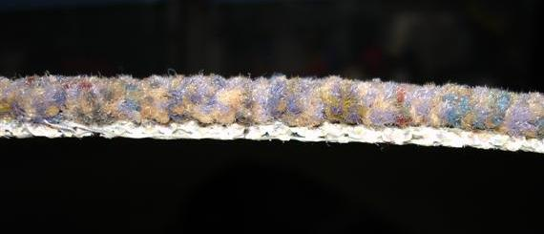
Diagram II.c.i: Fast Carpet

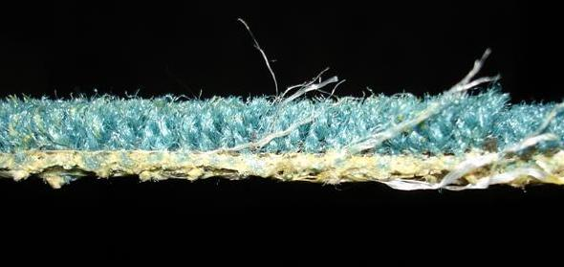
Diagram II.c.ii: Slow Carpet

  - Other Parts
    - Three (3): 1 lb Boxes 3" Thick Wood Screws (Used for Main Frame, Ends, and Legs)
    - One (1): 1 lb Box 2" Medium Thick Wood Screws (Used to Screw Down Plywood)
    - One (1): Box 9/16" Staples (Used to Staple Down Carpet)
    - Fourteen (14): 3/8" x 4" Threaded Screws (Used to Hold Side Boards Together and Anchor Middle Legs)
    - Eight (8): 3/8" x 6" Threaded Screws (Used to Anchor End Legs)
    - Twenty-four (24): 3/8" Nuts
    - Forty-eight (48): 3/8" Washers
    - Six (6): Leveling Feet
    - Paint, Varnish, or Stain
    - Set of Billiard Balls
    - Small Wooden Shims
    - Chicken Wire Mesh
  - Note I: Both of the carpetball tables that I have made have cost less than 200 dollars. I bought all of my parts at the Home Depot, except the pool balls (the single most expensive element at 50 dollars) and the carpet (which I found in a dumpster outside a carpet store (Don't worry, I asked permission before I took it!)).
  - Note II: I recommend using screws instead of nails because screws pull boards together while nails tend to push them apart and knock of the levelness.
  - Note III: Though I have done my best to accurately and precisely indicate dimensions, you may have to make slight adjustments of your own. If you make such adjustments, please email me (mfc5@duke.edu) so I can make changes if necessary. My advice would be to cut the parts as you need them, and not all at the beginning. Cross check my measurements... if someone makes a mistake it can only be fixed before the cutting!
- Tools:
  - 9/16" Staple Gun(s)
  - Belt Sander(s) and Appropriate Sand Paper
  - Cordless Drill(s)
  - Drill Bits (See Above for Sizes According to Screws Used)
  - Drop Cloths
  - Flat-Head and Philips Screwdriver(s)
  - Good Level(s)
  - Hack Saw
  - Hammer(s)
  - Hand-Saw or "Saws-All" Tool
  - Measuring Tape(s)
  - Paint or Varnish Brushes
  - Pencils, Pens, and Permanent Markers
  - Pliers
  - Razor Blade or Other Carpet Cutting Tool
  - Table Saw
  - T-square
  - Wrenches
- Framework
  - Use the level to ensure that the space you picked out is perfectly flat (This is crucial in the building process).
  - Lay out the two 10' x 1.5" x 7" boards and the two 7' x 1.5" x 7" boards (standing up) so that the junctions are not at the same place on the table (See Diagram IV.b). The two sides should be about 20 or 24 inches apart right now.
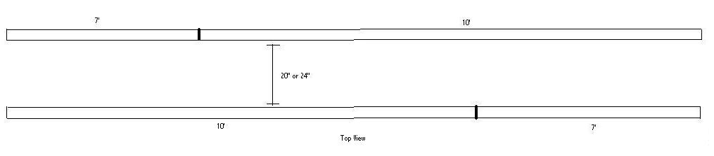
Diagram IV.b

  - Lay out the two 1' x 1.5" x 7" boards near the junctions. Drill four holes in the connecting boards and counter sink. Also, drill holes in the side boards and counter sink them, too. Thread the screws in, using washers on the ends. Screw on and tighten the bolts (See Diagram IV.c). Use the hacksaw to cut off the screw ends.
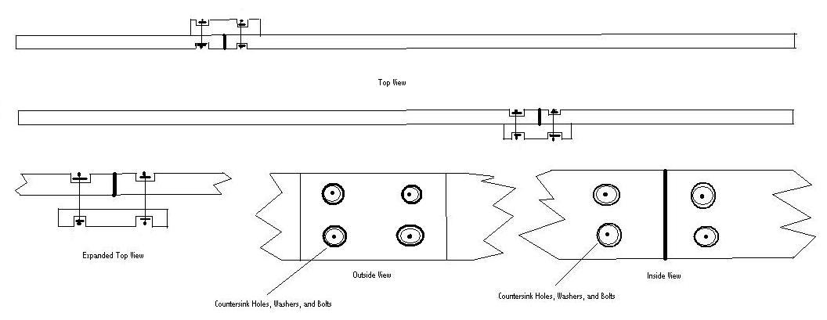
Diagram IV.c

  - Using a pencil, mark on the side boards as is indicated in Diagram IV.d. Measure from left to right in inches.
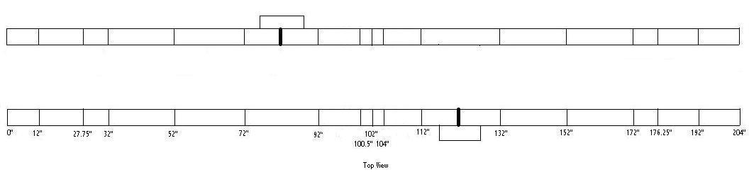
Diagram IV.d

  - Drill holes to the left and right of and above the 102-inch mark according to Diagram IV.e. Also, counter sink those holes on the inside. Thread the screws in, using washers on the ends. These screws will be used to secure the middle legs, and should be pointing towards the outside of the table. No bolts are needed for the outside yet.
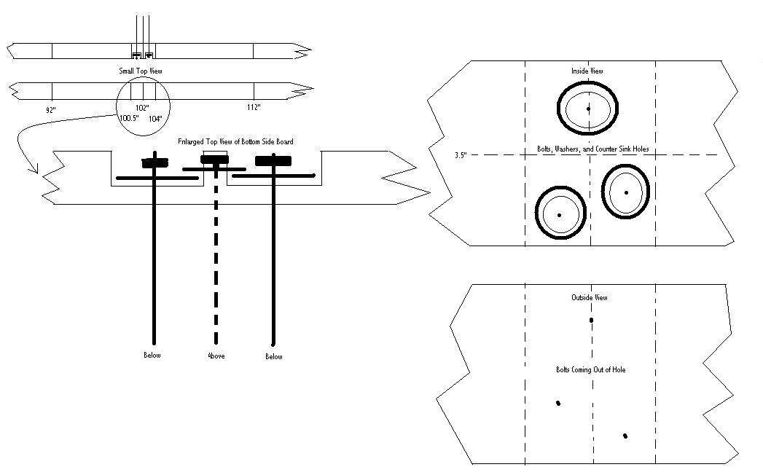
Diagram IV.e

  - Place the struts, centering them using the lines you drew two steps ago (See Diagram IV.f). Use the T-square to ensure that the struts make right angles with the side boards. Since the table is being made on the flat and level floor, the tops of the struts will be level too (even if they are not flush with the bottom of the [warped] side boards).
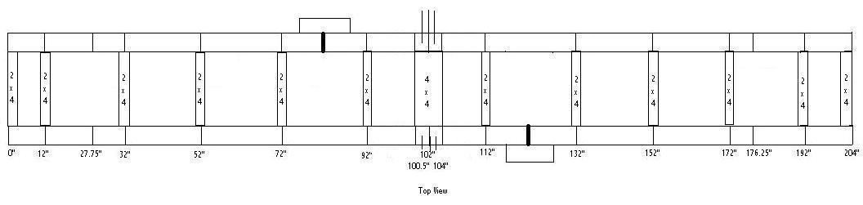
Diagram IV.f

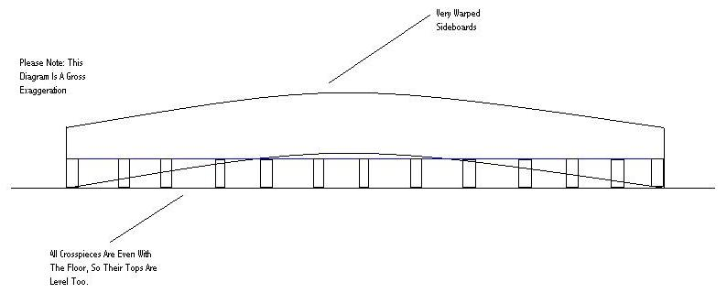
Diagram IV.f

  - Use the cordless drill to screw three 3" screws into both ends of each strut from the side boards. Use five screws for each side of the 4 x 4 strut (See Diagram IV.g).
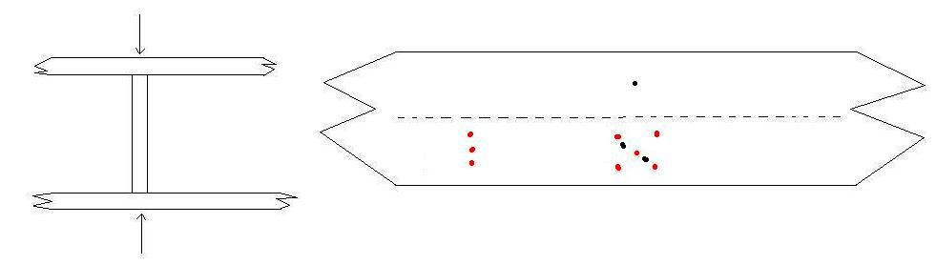
Diagram IV.g

  - Place the level across two struts at a time on the left, right, and center of the table for all of the struts (See Diagram IV.h). If a particular strut is not level with the others, unscrew the strut and move it up and down or side to side until it becomes level. If the struts are still not level, use the sander to even them out. Be careful, however, to not take off too much.
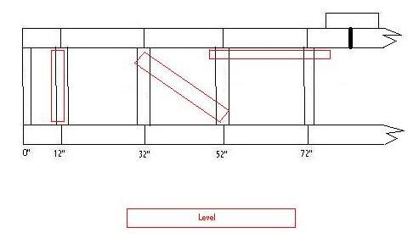
Diagram IV.h

  - Measure 1.5 inches from the end of each of the side boards. Bring one 2 x 4 to each end, and screw it into place at an angle according to the mark using 3" screws (See Diagram IV.i).
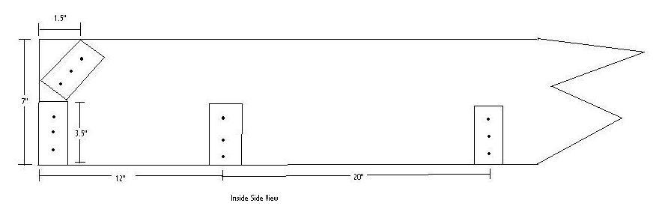
Diagram IV.i

  - Place the end and center angled supports in the places indicated in the diagram and screw them in using two or three 3" screws on each end (See Diagram IV.j). Have a helper hold the angled supports about half an inch below the tops of the struts and about half an inch above the floor. On the 20-inch model, the end angled supports will touch in the middle; on the 24-inch model, the end angled supports will not touch in the middle. The center angled supports will touch on neither model.
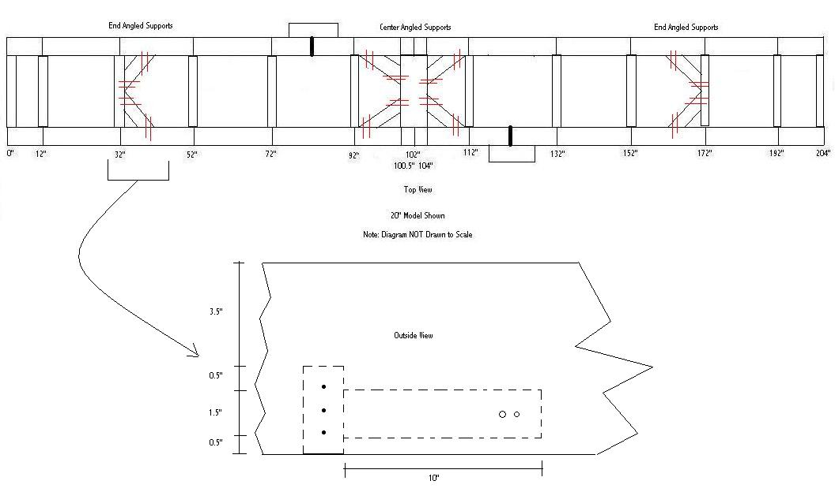
Diagram IV.j

- Plywood
  - Draw a line across the 4 x 4 in the middle of the table (this should be the 102" line). This line should divide the 4 x 4 in half the long way. Extend the line up the insides of the table so that it is clearly visible.
  - Place the large plywood planks on so that they meet at the line on the 4 x 4. Make them as flush together as possible. On the ends, they each should come within half an inch of the second to last strut (See Diagram V.b). This shortage on the ends allows the carpet to bend down into the pit (rather than bump out if the angle was sharp).
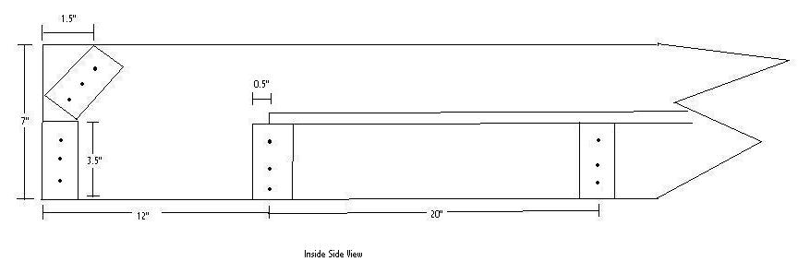
Diagram V.b

  - Screw the plywood down into the struts using the 2" screws. Work from the junction toward the table ends. Put three screws into each strut in the middle of the table, and four screws into the struts on the ends and the 4 x 4 junction strut.
  - Use the level to ensure that the plywood is perfectly level, both lengthwise and across the table, at every location and especially near the ends. If the surface is not level, use more screws to tighten down the plywood, or knock in a shim. If this fails, use the sander to even out bumps and bulges. Again, be careful not to take off too much. Also, keep in mind that you may need to re-level the table after it stands on its legs.
  - Turn the entire table over so that it is upside down.
  - Lay the remaining pieces of plywood over the ends where the pits will be and screw them in using the 2" screws (See Diagram V.f).
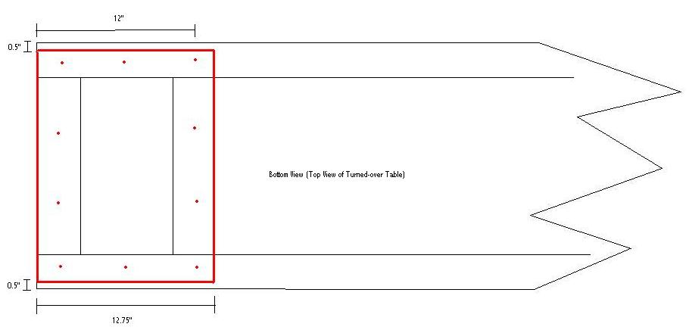
Diagram V.f

- Legs
  - Drill holes in the side boards between the 27.75" and 32" marks, and between the 172" and 176.25" marks (See Diagram VI.a). Counter sink the holes on the inside. Also drill holes in the end legs according to the diagram. You do not need to counter sink the holes in the legs, because the bolts will be beneath the table. You can find out where to make the holes in the legs by tapping a nail through the holes in the side boards to make small indentations on the leg.
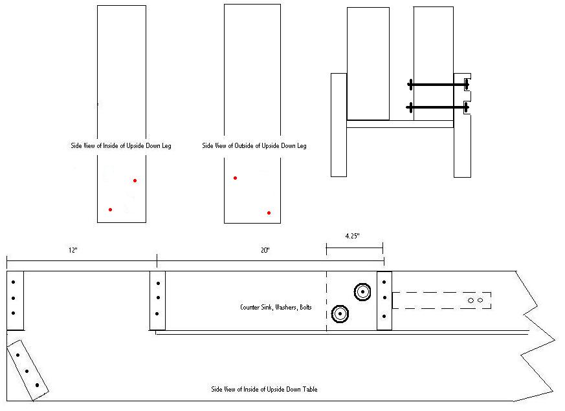
Diagram VI.a

  - Set the end legs over the table as indicated in Diagram VI.b. Make sure that they do not press up on plywood surface but are flush with it nonetheless (Because the struts were level with the floor, the plywood will be level also, and thus the legs which rest upon the plywood will be level). All of the weight should be on the side boards and the struts; none should be on the plywood. Use the T-square to ensure that the legs are at right angles to the struts.
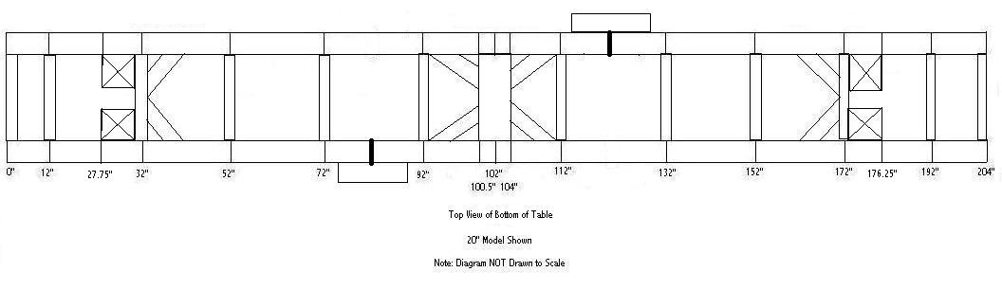
Diagram VI.b

  - Thread the 6" screws through the holes, add washers, and tighten the bolts. Use the hacksaw to cut of the screw ends.
  - Place the final two struts flush with the end legs (See Diagram VI.d). These struts need not necessarily touch the plywood; they are meant only to support the legs. Mount the final two struts using the 3" screws.
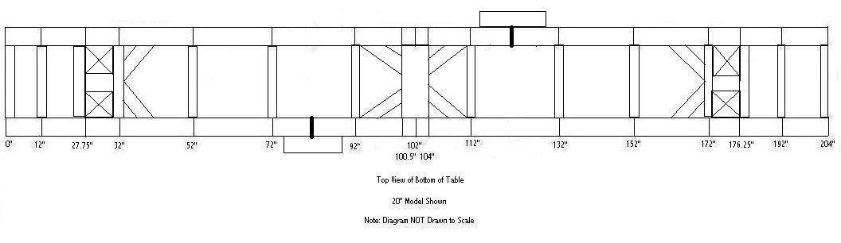
Diagram VI.d

  - Reinforce the end legs by anchoring with the 3" screws. Use three screws on each side if possible. The end legs should now be anchored on three sides each.
  - Drill holes in the middle legs according to Diagram VI.f. Counter sink these holes. You can find out where to make the holes in the legs by tapping the legs against the screws protruding from the sideboards so that small indentations are made.
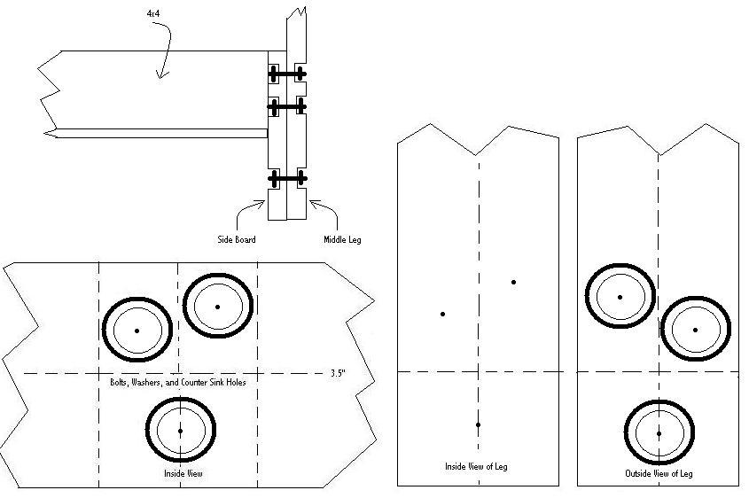
Diagram VI.f

  - Fit the middle legs to the side boards through the screws. (See Diagram VI.g). Add the washers and lightly screw on the bolts. Tighten the bolts by holding the screw with pliers and turning the bolt with a wrench. Use the hacksaw to cut off the screw ends. Reinforce the middle legs by anchoring with 3" screws.
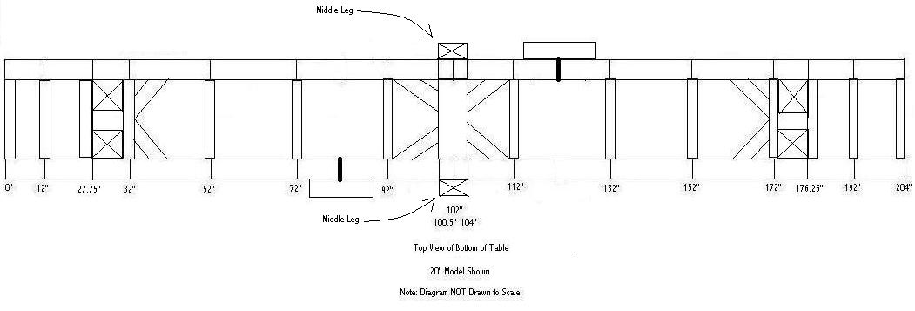
Diagram VI.g

  - Use the measuring tape to ensure that the distance between each pair of legs is constant through the entire length. Also, measure the height of each leg (do not use the level; this could result in irregular results due to faults in the side boards) from the plywood to the end. If the legs are too long, sand (do not cut) the legs ever so slightly until they are perfect (See Diagram VI.h). Do not add shims between the plywood and the legs.
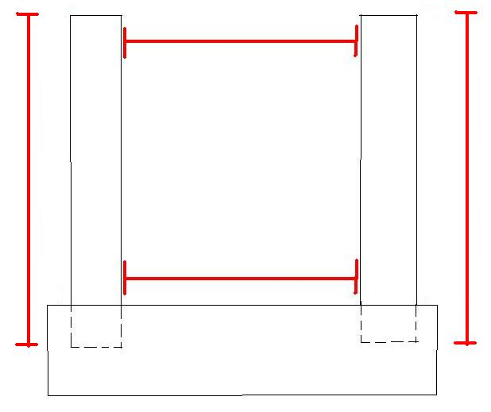
Diagram VI.h

  - Using the 3" screws, mount the leg cross pieces between each leg pair (See Diagram VI.i).
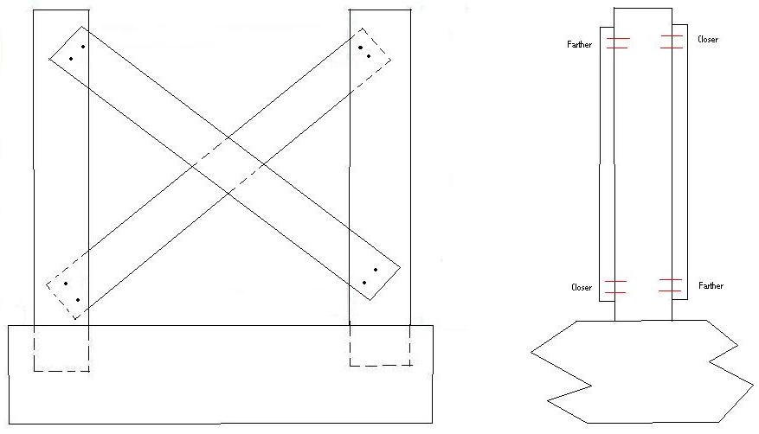
Diagram VI.i

  - Fix the six leveling feet to the bottom of the legs according to the instructions included with the feet.
- Leveling and Surfacing
  - Carefully turn the table over again so that it is right side up.
  - Use the level to ensure that the table's playing surface is still flat. If there are irregularities...
    - First ensure that the legs are not putting pressure on the plywood.
    - If this is the case, turn the table all the way over and adjust the problematic leg(s) by unscrewing them and sanding the parts of them that is near the plywood.
    - If this fails, try carefully sanding the legs again.
    - If the irregularities are small, you can use the leveling feet to fix the problem.
  - Sand every last inch of the table that will be touched by hands or feet- including the table legs. Splinters are no fun, and sanding also makes the table easier to varnish or paint.
  - Lay down the drop cloth. Paint, varnish or stain the table several times... it will be getting a lot of abuse so the more protection the better.
- Carpeting
  - Drape the largest and longest piece of carpet over the table and over the ends. Align it with the ends of the table so it is perfectly straight.
  - Using the staple gun, staple the carpet to the plywood under the ball pit. There should be between 8 and 12 inches of carpet under this part of the table (See Diagram VIII.b).
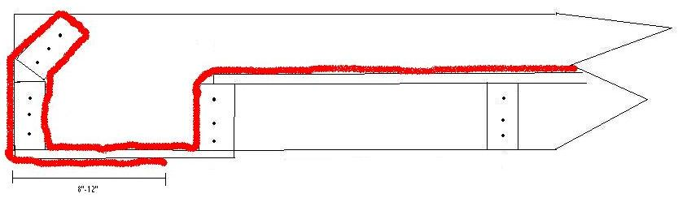
Diagram VIII.b

  - Use the flathead screwdriver and the hammer to fully drive in the staples if necessary.
  - Pull the carpet and continue stapling up the outside of the back wall and into the pit. Use the screwdriver to push the carpet into the tight corners of the pit.
  - Push the carpet out of the pit and up onto the playing surface. The carpet should form a nice round bend when sloping up from the pit onto the table.
  - Staple the carpet on the playing surface 4 times at each stud along the way, and a few extra times around the junction of the two pieces of plywood. Remember to use the flathead screwdriver and the hammer to fully pound in the staples.
  - Repeat the last six steps in reverse order once you reach the other end of the table.
    - Note: If two pieces of carpet are being used, scrunch the two pieces as close together as possible on anywhere but the 102-inch line, and run a line of staples completely down one end and completely down the other.
  - Use a new, sharp razor to trim off any extra carpet on the end under the table.
  - Staple the two long strips of carpet to the walls of the table in the same fashion as above.
  - Staple the four pit wall pieces of carpet into the pit sides. They will be tight, so use the "bubble method:"
    - Make a "bubble" out of the carpet by inserting the top and bottom parts first.
    - Staple the bubble down.
- Final Steps
  - Line up six Billiard Balls on each side of one end of the table. Using the permanent marker, draw a line from one side of the table to the other connecting the farthest pool balls (See Diagram IX.a).
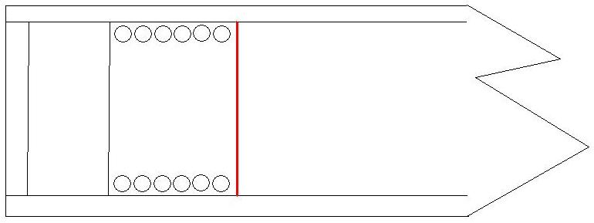
Diagram IX.a

  - Repeat the previous step at the other end of the table
  - Rotate the leveling feet until the table is level, or at least until balls placed on the table do not roll.
  - An optional add-on to protect your furniture and other players involves stapling a chicken wire mesh over the table's playing surface so balls cannot fly out.
  - If you would, please write my name (Matthew Campbell) and this web site's URL (http://www.duke.edu/~mfc5/ultracarpetballplans/) under the table for reference and credit.
  - Let the games begin!

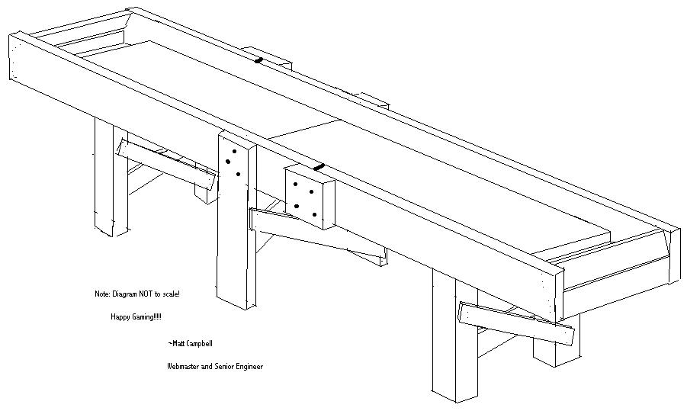
© 2006 Matthew Campbell

