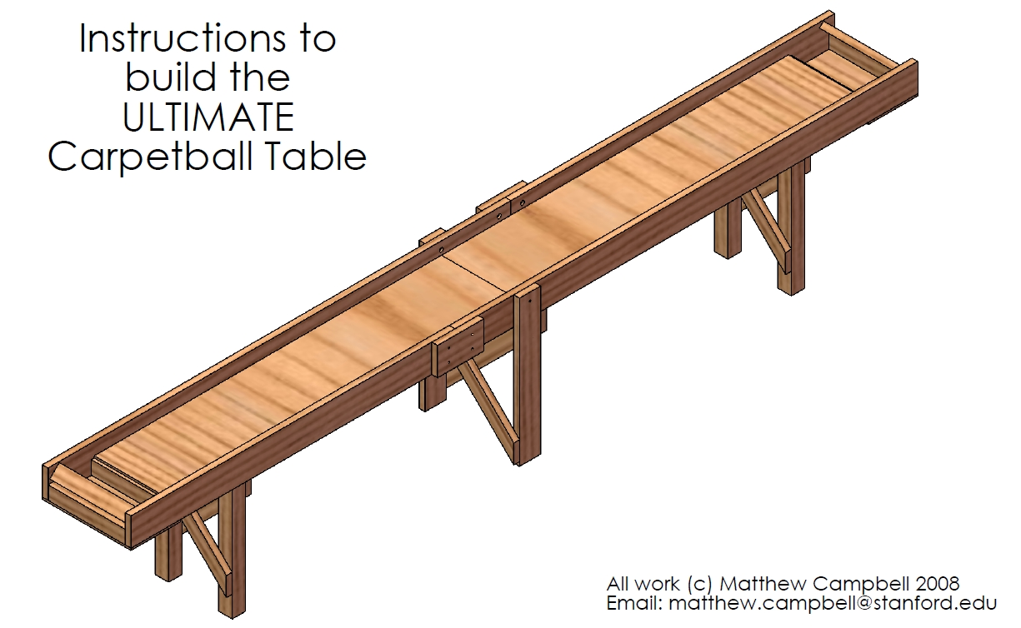

Ultra Carpetball Plans
Matthew Campbell
http://www.mcampbell.info/carpetball/
matthew.campbell@stanford.edu

These plans are made to be used along with the Bill of Materials PDF and the Instructions PDF

Disclaimers
Building:
I wish I could say that using a saw or a drill was easy, but it's not and it's risky and you can get hurt- I certainly have! Therefore, I must say that I can take no responsibility for any injuries that are incurred as any part of the building process of carpetball tables or anything related. Since you are putting together the table, it is your responsibility to make sure you do it safely. That said, if you do notice places in the assembly process that are unsafe, or you have any recommendations to make, I always welcome comments and concerns so please send them to matthew.campbell@stanford.edu.
Playing Carpetball:
I'm not gonna lie, anyone who says that carpetball is not a contact sport is wrong. If you are standing around or near or even in the same room as the table, chances are you will get hit with a ball, flailing arm, or some other object, and it will hurt. That said, in all seriousness, play at your own risk and have fun but don't kill yourselves! Basically, I can not and will not take any responsibility for any injuries incurred while playing carpetball or any of its derivatives. However, as above if you do see methods of design not already mentioned in the plans that could make the table and play safer, please email them to matthew.campbell@stanford.edu.
These Plans:
As an engineering student, I do my best to make sure that these plans are as error-free as possible. I've been told in an email or two that if you bring the plans to the hardware store and ask them to cut the parts there, everything fits together with no problems at all. However, nobody is perfect and there could be some flaws that haven't come up yet. If you find some, do your best to work around, and make sure you contact me at matthew.campbell@stanford.edu about them quickly! I'll work hard to fix the errors in the plans so no one else has to deal with them. But since I do offer these plans for free, I must say that I cannot take responsibility for any flaws you may find and any problems that occur as a result of them.
Downloads:
Wow, this is a lot of disclaimers. Almost there! I try to make sure that the files you get off of this site are free from errors and viruses etc. However, in the unlikely event that something does creep up somehow, I say here that I cannot take responsibility for it. But you know the drill by now- if you do find a problem, just email me at matthew.campbell@stanford.edu to alert me of the problem, and I will work to get it fixed. Cheers for everything, and happy building and gaming!

I. Preparation
- Read these instructions all the way through and look at all the diagrams before starting! It's important to have a visual picture in your head of what you'll be building, so make sure you understand what you're getting into!
- Find out if you have a 4-foot by 22-foot space for a carpetball table (this includes room on each end and on the sides). Remember that you will put together the table where it will be played; it is too big and heavy to move after being assembled.
- Choose a 20-inch wide ("hard") or 24-inch wide ("easy") table. The plans I have drawn up work for a 20-inch table (I think that a skinnier table is more difficult and fun to play). If you want a 24-inch table, you can keep the same dimensions for all the parts except:
  - 20-inch 2x4's --> 24-inch 2x4's
  - 20-inch 4x4 --> 24-inch 4x4
  - 23-inch end plywood --> 27-inch end plywood
  - 20-inch main plywood --> 24-inch main plywood
  - 31.78-inch end leg cross supports --> 37.44-inch end leg cross supports
  - 40.27-inch leg middle leg cross supports --> 45.93-inch middle leg cross supports
- Choose between a "slow" table (balls don't roll as easily; uses thicker, more expensive carpet) or a "fast" table (balls roll with the slightest touch; uses thinner, cheaper carpet). Remember though, that the terms slow and fast are completely relative because that all depends on how fast you throw the cue ball.
- Note: I have made a number of carpetball tables in my lifetime; some easy and "fast," and some hard and "slow." The majority of players, including myself, have decided that the hard and "slow" tables were much more exciting to play.
II. Parts
Due to board sanding, there is a difference between actual size and listed size. For example, a board listed as 2" x 4" board might actually be 1.5" x 3.5". To see a list of actual sizes compared to list sizes, see Engineer's Edge.
You can often buy all these parts for less than $300 at Home Depot. You can just ask a local carpet vendor if they have any spare carpet you can have.
I recommend using screws instead of nails because screws pull boards together while nails tend to push them apart and knock of the levelness.
Cross-check my measurements; if you find any problems please email me at matthew.campbell@stanford.edu.
- Main Table Parts
  - Side boards: (2x): 10 ft x 2x8 (Some individuals recommend using 2x10 side boards; this could help prevent balls from flying out but may make throwing them more difficult. If 2x10 boards are used, shorten legs by 1.5” and use a 2x6 for the angled backboard rather than a 2x4)
  - Side boards: (2x): 7 ft x 2x8
  - Side connectors: (2x): 1 ft x 2x8 (you can make this 1.5 ft as well)
  - Cross beams: (16x): 20 in x 2x4
  - Center cross beam: (1x): 20 in x 4x4
  - End angled supports: (4x): (see Diagram II.a.vi)
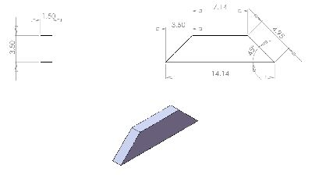
Diagram II.a.vi
  - Middle angled supports: (4x): (see Diagram II.a.vii)
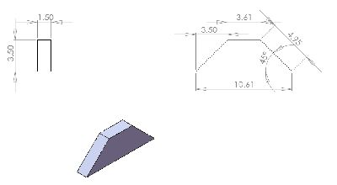
Diagram II.a.vii
  - Long plywood: (2x): 20 in x 90 in x .5 in
  - End plywood: (2x): 23 in x 12.75 in x .5 in
- Legs
  - End table legs: (4x): 34 in x 4x4
  - Center table legs: (2x): 37.75 in x 2x6
  - End leg supports: (4x): (see Diagram II.b.iii)
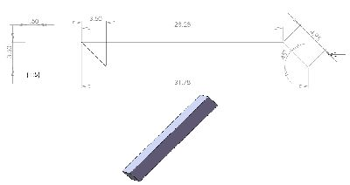
Diagram II.b.iii
  - Middle leg supports: (2x): (see Diagram II.b.iv)
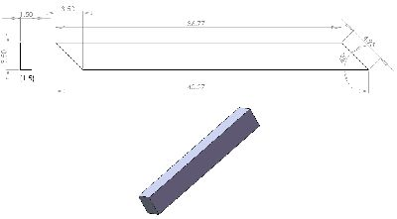
Diagram II.b.iv
  - Leg thrust supports: (4x): (see Diagram II.b.v)
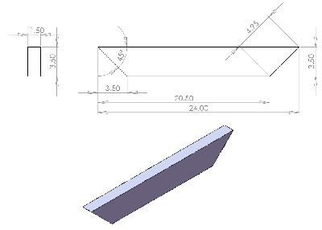
Diagram II.b.v
- Carpet
  - Carpet surface: (1x): 20 in x 22 ft (you can break this up into 2-3 shorter strips if need be; just avoid joining them at the plywood junction)
  - Carpet walls: (2x): 3 in x 200 in
  - Carpet for pit walls: (4x): 3 in x 9.5 in
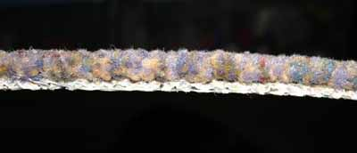
Diagram II.c.i: Fast Carpet
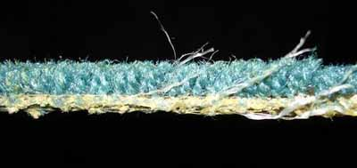
Diagram II.c.ii: Slow Carpet
- Other Parts
  - Frame screws: (3x): 1 lb box 3 in long thick wood screws
  - Plywood screws: (1x): 1 lb box 2 in long medium wood screws
  - Carpet staples: (1x): Box 9/16 in staples
  - Upper side board and middle leg bolts: (6x): 3/8 in x 2.5 in threaded bolts
  - Lower side board bolts: (4x): 3/8 in x 3.5 in threaded bolts
  - End leg bolts: (8x): 3/8 in x 5.5 in threaded bolts
  - Nuts: (18x): 3/8 in nuts
  - Washers: (36x): 3/8 in washers (also try lock washers)
  - Paint, varnish, or stain
  - Set of billiard balls
  - Leveling feet: (6x): leveling feet (optional)
  - Small Wooden Shims (optional)
  - Chicken Wire Mesh (optional)
III. Tools
- Tools
  - 9/16" Staple gun(s)
  - Belt sander(s) and appropriate sand paper
  - Cordless drill(s)
  - Drill bits (see above for sizes according to bolts / screws used)
  - Drop cloths
  - Flat-head and philips screwdriver(s)
  - Good level(s)
  - Hack saw
  - Hammer(s)
  - Hand-saw or "saws-all" tool
  - Measuring tape(s)
  - Paint or varnish brushes
  - Pencils, pens, and permanent markers
  - Pliers
  - Razor blade or other carpet cutting tool
  - Table saw
  - T-square
  - Wrenches
IV. Framework
- Use the level to ensure that the space you picked out is perfectly flat (This is crucial in the building process).
- Lay out the two 10 ft x 2x8 boards and the two 7 ft x 2x8 boards (standing up) as in See Diagram IV.b. The two sides should be about 20 inches apart right now.
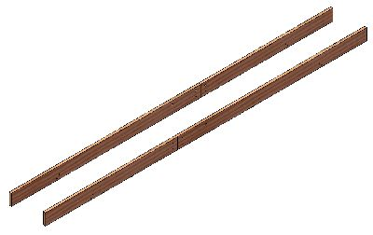
Diagram IV.b
- Lay out the two 1 ft x 2x8 boards near the junctions. Drill four holes in the side boards and counter sink the upper two holes (so the carpet can be flush). Also, drill holes in the connector boards in the same place. Thread the 2.5 inch bolts into the upper holes and the 3.5 inch bolts into the lower ones, using washers on both ends. Screw on and tighten the nuts (See Diagram IV.c). Use the hacksaw to cut off the extra bolt length, if any.
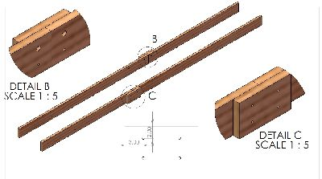
Diagram IV.c
- Place the struts, according to Diagram IV.d. Use the T-square to ensure that the struts make right angles with the side boards. Since the table is being made on the flat and level floor, the tops of the struts will be level too (even if they are not flush with the bottom of the [warped] side boards).
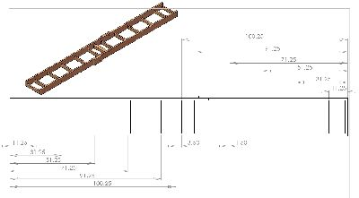
Diagram IV.d
- Use the cordless drill to screw three 3" screws into both ends of each strut from the side boards. Use five screws for each side of the 4 x 4 strut. It often helps to pre-drill the holes before inserting screws.
- Place the level across two struts at a time on the left, right, and center of the table for all of the struts (See Diagram IV.f). If a particular strut is not level with the others, unscrew the strut and move it up and down or side to side until it becomes level. If the struts are still not level, use the sander to even them out. Be careful, however, to not take off too much.
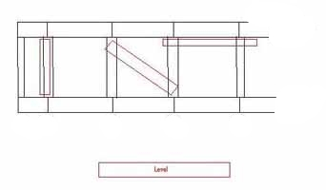
Diagram IV.f

V. PLywood
- Draw a line across the 4x4 in the middle of the table (this should be the 102-inch line). This line should divide the 4x4 in half the long way. Extend the line up the insides of the table so that it is clearly visible.
- Place the large plywood planks on so that they meet at the line on the 4x4. Make them as flush together as possible. On the ends, they each should come to 0.75 inch of the second to last strut (See Diagram V.b). This shortage on the ends allows the carpet to bend down into the pit (rather than bump out if the angle was sharp).
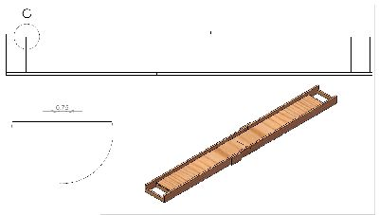
Diagram V.b
- Screw the plywood down into the struts using the 2 inch screws. Work from the 4x4 out toward the table ends. Put three screws into each strut in the middle of the table, and four screws into the struts on the ends and the 4x4 junction strut.
- Use the level to ensure that the plywood is perfectly level, both lengthwise and across the table, at every location and especially near the ends. If the surface is not level, use more screws to tighten down the plywood, or knock in a shim. If this fails, use the sander to even out bumps and bulges. Again, be careful not to take off too much. Also, keep in mind that you may need to re-level the table after it stands on its legs.
- Fit in the back board at an angle suitable to you. I shoot for about 45 degrees (the point of the 2x4 is about 1.5 inches from the end of the side beam), but this is trial and error (be careful when testing; there is no carpet yet to dull the ball's force). Bring one 2x4 to each end, and screw it into place at an angle according to the mark using 3 inch screws (See Diagram V.e). This 2x4 gets the most beating of any on the table, so take great care in screwing it in well. You may want to pre-drill the holes to avoid splitting the wood at this fragile junction.
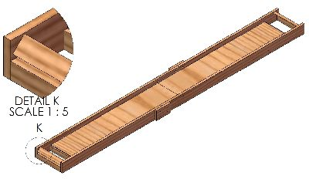
Diagram V.e
- Turn the entire table over so that it is upside down.
- Place the end and center angled supports in the places indicated in the diagram and screw them in using two or three 3 inch screws on each end (See Diagram V.g).
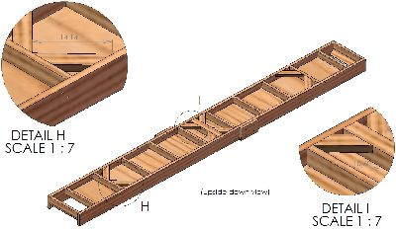
Diagram V.g
- Lay the remaining pieces of plywood over the ends where the pits will be and screw them in using the 2 inch screws (See Diagram V.h).
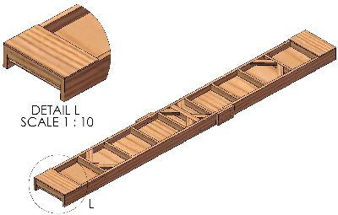
Diagram V.h
VI. Legs
- Drill holes in the top of the middle and center legs according to the diagram (Diagram VI.a). Place the legs in position on the plywood. Make sure that the end legs do not press up on plywood surface but are flush with it nonetheless. Doing this ensures that the end legs will be level, because the plywood is attached to the struts which were level according to the flat floor. Some individuals use small cardboard inserts between the plywood and the legs to ensure that the legs are level for construction, and then remove the cardboard after the legs are secure to produce a small gap. There is no good trick to ensure that the middle legs will be level; just be careful. Tap through these holes with a screw driver to mark where on the side boards to drill, and then drill these holes. Thread bolts through (5.5 inch for the end legs; 2.5 inch for the middle legs) and secure with washers and nuts. Each end leg gets 2 bolts; each middle leg gets 1 bolt. Further secure each leg with 3 inch wood screws. Ultimately, the legs should be applying force directly to the struts and side beams, but not the plywood. If the legs push on the plywood, it will warp.
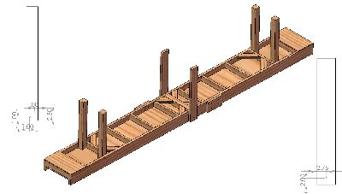
Diagram VI.a
- Place the final two struts flush with the end legs (See Diagram VI.b). These struts need not necessarily touch the plywood; they are meant only to support the end legs. Mount the final two struts using the 3" screws.
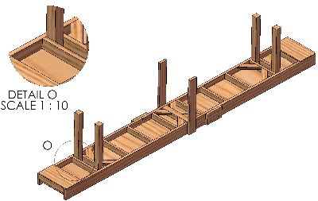
Diagram VI.b
- Reinforce the end legs by anchoring with the 3" screws. Use three screws on each side if possible. The end legs should now be anchored on three sides each.
- Use the measuring tape to ensure that the distance between each pair of legs is constant through the entire length. Also, measure the height of each leg (do not use the level; this could result in irregular results due to faults in the side boards) from the plywood to the end. If the legs are too long, sand (do not cut) the legs ever so slightly until they are perfect (See Diagram VI.d). Do not add shims between the plywood and the legs.
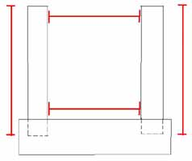
Diagram VI.d
- Using the 3" screws, mount the leg cross pieces between each leg pair (See Diagram VI.e).
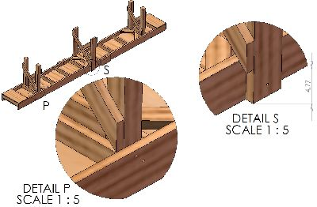
Diagram VI.e
VII. Leveling and Surfacing
- Carefully turn the table over again so that it is right side up.
- Use the level to ensure that the table's playing surface is still flat. If there are irregularities...
  - First ensure that the legs are not putting pressure on the plywood.
  - If this is the case, turn the table all the way over and adjust the problematic leg(s) by unscrewing them and sanding the parts of them that is near the plywood.
  - If this fails, try carefully sanding the legs again.
  - If the irregularities are small, you can use the leveling feet to fix the problem.
- Sand every last inch of the table that will be touched by hands or feet- including the legs. Splinters are no fun, and sanding also makes the table easier to varnish or paint.
- Lay down the drop cloth. Paint, varnish or stain the table several times... it will be getting a lot of abuse so the more protection the better.
VIII. Carpeting
- Drape the largest and longest piece of carpet over the table and over the ends. Align it with the ends of the table so it is perfectly straight.
- Using the staple gun, staple the carpet to the plywood under the ball pit (you could also glue down the carpet if you want to avoid using a stapler). There should be between 8 and 12 inches of carpet under this part of the table (See Diagram VIII.b).
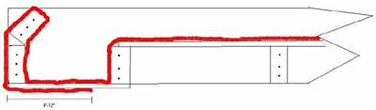
Diagram VIII.b
- Use the flathead screwdriver and the hammer to fully drive in the staples if necessary.
- Pull the carpet and continue stapling up the outside of the back wall and into the pit. Use the screwdriver to push the carpet into the tight corners of the pit.
- Push the carpet out of the pit and up onto the playing surface. The carpet should form a nice round bend when sloping up from the pit onto the table.
- Staple the carpet on the playing surface 4 times at each stud along the way, and a few extra times around the junction of the two pieces of plywood. Remember to use the flathead screwdriver and the hammer to fully pound in the staples.
- Repeat the last six steps in reverse order once you reach the end of the table.
  - Note: If two pieces of carpet are being used, scrunch the two pieces as close together as possible on anywhere but the 102-inch line, and run a line of staples completely down one end and completely down the other.
- Use a new, sharp razor to trim off any extra carpet on the end under the table.
- Staple the two long strips of carpet to the walls of the table in the same fashion as above.
- Staple the four pit wall pieces of carpet into the pit sides. They will be tight, so use the "bubble method:"
  - Make a "bubble" out of the carpet by inserting the top and bottom parts first.
  - Staple the bubble down.
IX. Final Steps
- Line up six Billiard Balls on each side of one end of the table. Using the permanent marker, draw a line from one side of the table to the other connecting the farthest pool balls (See Diagram IX.a).
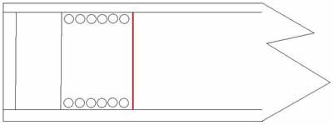
Diagram IX.a
- Repeat the previous step at the other end of the table
- If you installed leveling feet, rotate them until the table is level, or at least until balls placed on the table do not roll on their own accord.
- An optional add-on to protect your furniture and other players involves stapling a chicken wire mesh over the table's playing surface so balls cannot fly out. I think this makes it a little less fun to play because it limits the types of throws you can use, but it is a bit safer.
- For extra protection, try carpeting parts of the outside of the table.
- To prevent the table from tipping over accidentally, you might try placing it against a wall and securing it there using straps between the legs and screws in the wall.
- To help other people build tables, please write my name (Matthew Campbell) and this web site's URL (http://www.mcampbell.info/carpetball/) under the table for reference. If you want, you can just print out Diagram IX.e and glue it to the bottom of the table.
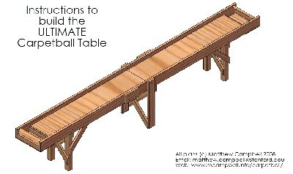
Diagram IX.e
- Let the games begin!

